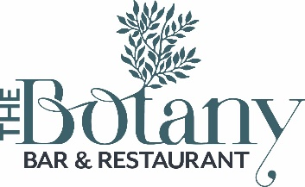
Winter lunch menu – available to 3pm
Freshly made soup of the day £5.45 (vg+v)
Chicken liver parfait with toasted brioche & onion chutney £6.75
Hot & sour soup with prawns £7.95 or with tofu £6.75 (v)
Smoked salmon pate with crispbreads £6.95
Warm brie and cranberry tart £6.95 (v)
Vegetable pakora (vg) £6.75

Pan fried hake with fries and crushed minted peas £12.95
Smoked haddock risotto £13.00
Vegetable sausage and mash £11.50 (v)
Roast tofu on pine nut and apricot cous-cous and spinach £10.50 (vg)
The Botany beef burger with cheddar, fries and slaw £11.00
Beer battered haddock, mushy peas and hand cut chips £11.50
Roast breast of chicken with black pudding mash and port gravy £11.95

…………………………………………………………………………….

Open sandwiches
Smoked salmon with dill mayo £6.95
Grilled halloumi with hummus and harissa mayo £6.50
Coronation chicken £6.45
Ciabatta sandwiches
Steak and onion £7.95
Brie and bacon £6.95
Add soup or skinny fries for £2.50

